- Motivate your students to settle down with a visually inspiring activity provided by the homepage of the Bing in the Classroom program. Help them to build their search skills and increase their digital literacy with these fun and educational exercises.

NAVIGATING THE BING HOMEPAGE:

- Hover over the homepage image to reveal hotspots.

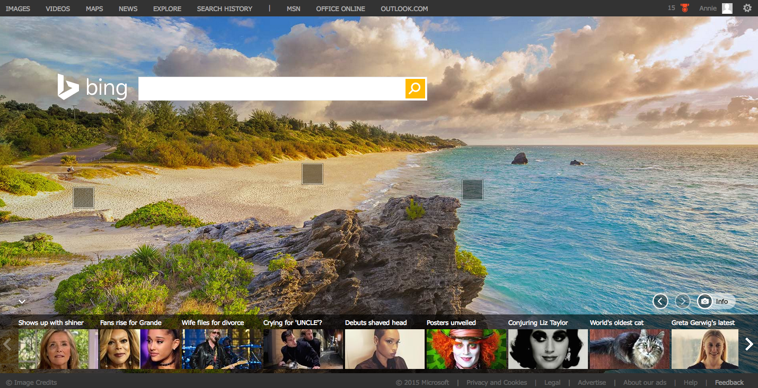

- Hover over a hotspot to reveal information about the homepage image
- 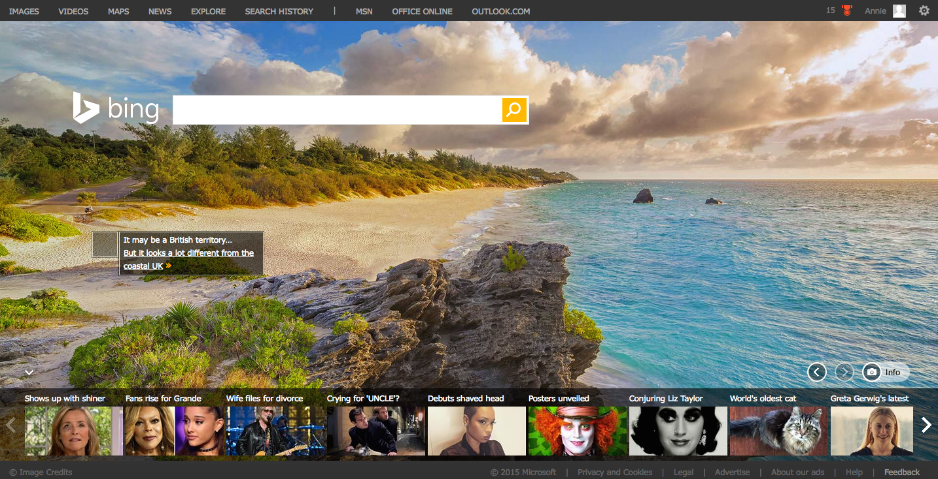

- Hover over the camera to reveal the name of the photo

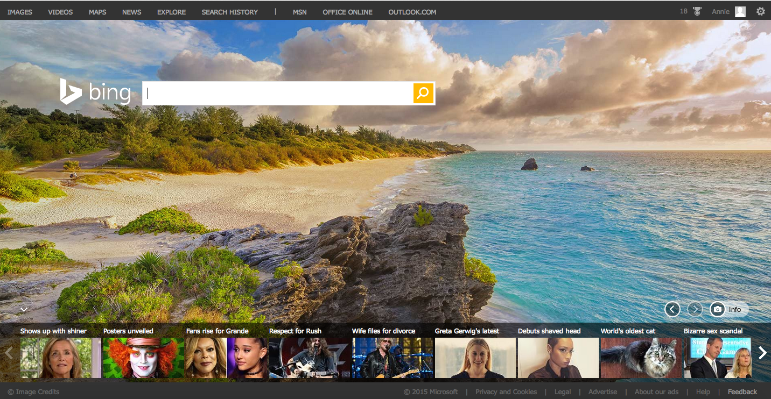
  - You can view past images by clicking on the left arrow located in the lower right-hand side.
  - Click the camera and info button that takes you to a page dedicated to facts about the homepage image

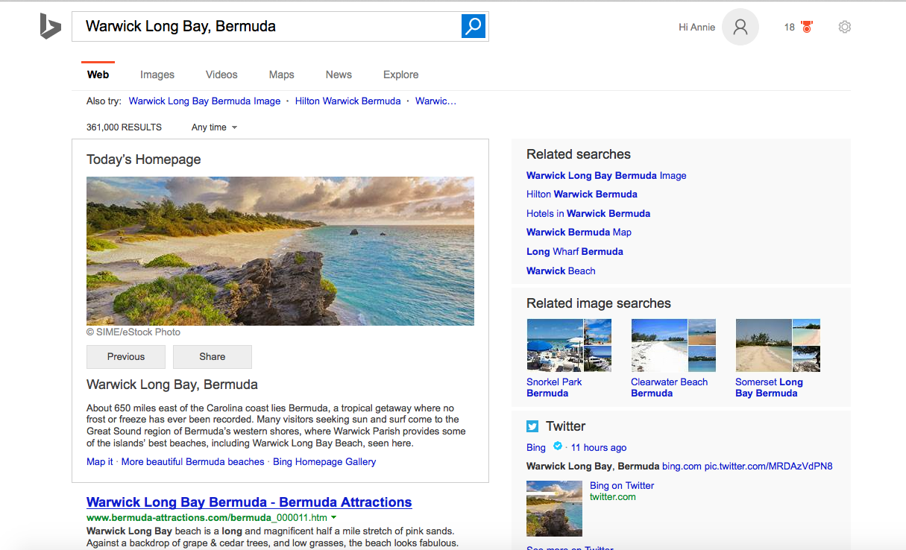

Activity:

Find one of each of the following for today’s homepage image:
  - Website:
  - Image:
  - Video:
  - Map:
  - News article:

- Find additional activities below and/or clicking on a tab to the right.

Activities:

Basic search

In the search bar, type in [teachers, please choose a topic/keyword] and click on the magnifying glass.

How many results did Bing return?

Choose a web page that is relevant to the topic you searched for and copy/paste the link here:

Finding an image

Click on Image under the search bar.

Choose an image that is relevant to the topic you searched for and copy/paste the link here:

Finding a Video

Click on Video under the search bar.

Choose an image that is relevant to the topic you searched for and copy/paste the link here:

Finding a Map

Click on Map under the search bar.

Choose a map that is relevant to the topic you searched for and copy/paste the link here:

Finding a News Article

Click on News under the search bar.

Choose an article that is relevant to the topic you searched for and copy/paste the link here:

Exploring other topics

Click on Explore under the search bar.

Here you can find other featured news, videos, beautiful Bing gallery images etc.

Choose a topic that is interesting to you and copy/paste the link here:

Return to the Bing homepage by clicking on the Bing logo at the top left corner.

Browse popular images, videos, maps and news with Bing.

Activities:

Finding an image

Click on Images at the top left corner

Here you can find images of popular people, animals nature and wallpaper searches.

Choose one of each and copy/paste the links below:

Popular people:

Popular animal:

Popular nature:

Popular wallpaper:

Finding a video

Click on Videos at the top navigation

Here you can find popular music videos, viral videos, clips of television shows and movie trailers.

Choose one of each of the following and copy/paste the links below:

Music Video:

Viral Video

TV shows:

Movie Trailers:

Finding a Map

Click on Maps at the top navigation

Here you can find maps of foreign countries and different areas of the United States like Redmond, Washington or New York, New York.

Find a map of each the following and the copy/paste the links below:

Country:

State:

City:

You can also find driving, transportation and walking directions to places by clicking on “Directions” located under the Bing logo in the left hand corner.

Practice searching for the different kinds of directions for traveling from your home to your school.

Finding a News Article

Click News at the top navigation

Here you can find articles of top stories, US news, world, local, entertainment, sci/tech, business, politics, sports, health and products.

Find an interesting article of each section and copy/paste them below:

Top news:

US:

World:

Local:

Entertainment:

Sci/Tech:

Business:

Politics:

Sports:

Health:

Products:

Explore

Click Explore at the top navigation

Here you can find topics featured on Bing and explore other cool offerings from Bing including gallery homepage articles.

Choose one of the featured topics of this week and copy/paste the its link here:

Search History

Click Search History at the top navigation

Here you can find a list of past searches categorized by keyword and type of search, i.e. video, images.

Type a keyword to search within the search history.

Practice filtering by type by clicking “All types” and choosing Web, Video or Image.

Practice filtering by date by clicking “All dates” and selecting a date on the calendar.

Practice turning off and clearing the search history by clicking on “Turn off” and “Clear all” located on the right side of the results.

Return to the Bing homepage by clicking on the Bing logo at the top left corner.

Find out what topics are trending now with hotspots.

What are hotspots?

On the Bing homepage, there is a news carousel located at the bottom, also known as hotspots. Each hotpot will link off articles of a news topic that is currently trending.

Activity: Click on a hotspot and choose an interesting article. Write a short summary of the article below and be sure to copy/paste the article link below.

Article link:

Summary:

